Given a m * n matrix mat of integers, sort it diagonally in ascending order from the top-left to the bottom-right then return the sorted array.

**Example 1:**

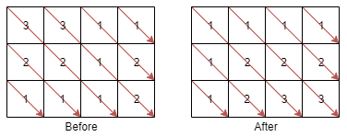

**Input:** mat = [[3,3,1,1],[2,2,1,2],[1,1,1,2]]

**Output:** [[1,1,1,1],[1,2,2,2],[1,2,3,3]]

**Constraints:**

* m == mat.length
* n == mat[i].length
* 1 <= m, n <= 100
* 1 <= mat[i][j] <= 100